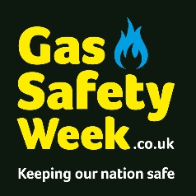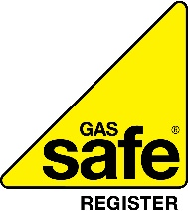

Gas Safety Week: Fighting for a Gas Safe Nation
Helping everyone stay gas safe
We are proud to be supporting Gas Safety Week 2023, taking place 11 – 17 September.
Gas Safety Week is an annual safety week to raise awareness of gas safety and the importance of taking care of your gas appliances. It is coordinated by Gas Safe Register, the official list of gas engineers who are legally allowed to work on gas.
Badly fitted and poorly serviced gas appliances can cause gas leaks, fires, explosions, and carbon monoxide (CO) poisoning. CO is a highly poisonous gas that can kill quickly and without warning, as you cannot see it, taste it or smell it.
By taking care of your gas appliances properly you are taking care of your home, your loved ones and even looking out for your local community. Follow these few simple checks to keep you and others safe.
- Check your Landlord’s Gas Safety Record. By law, your landlord must keep gas pipework, appliances and flues supplied for you to use in good condition. They must arrange a gas safety check of the appliances and flues every year and give you a record of the check. If your landlord refuses to provide you with one, you can report their details to the HSE: https://bit.ly/LGSRReport1

- Check for warning signs that could indicate your (or others) gas appliances are not working correctly. Signs may include lazy yellow /orange flames instead of crisp blue ones, error messages or unexpected noises from your boiler or dark and sooty stains around your gas appliance. Contact your landlord, or, if you own the appliance, a Gas Safe registered engineer to check it. You can find a registered engineer at GasSafeRegister.co.uk or by calling 0800 408 5500.

- Know the six main symptoms of carbon monoxide poisoning – headaches, dizziness, breathlessness, nausea, collapse, and loss of consciousness.

- Install an audible carbon monoxide alarm and look out for your community by making sure your friends, relatives and neighbours have one too. Check they are marked EN50291 and display the British Standards’ Kitemark.

- Get your own gas appliances safety checked annually. Your landlord is not responsible for gas appliances that you own, so you should arrange for these to be safety checked once a year and serviced regularly by a Gas Safe registered engineer. Set a reminder so you don’t forget at StayGasSafe.co.uk.

- Check your engineer is qualified for the type of gas work you need doing e.g., natural gas, domestic boiler. You can find this information on the back of their Gas Safe ID card and the Gas Safe Register website.

For gas safety advice and to find or check an engineer visit the Gas Safe Register website at GasSafeRegister.co.uk.

